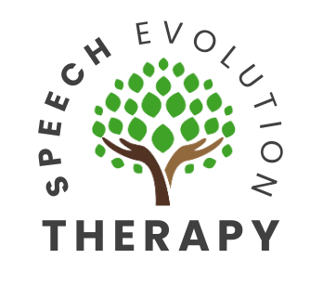
Referral Criteria for Pediatric Speech-Language Evaluation

2 to 2½ Year Old

The first 3 years of your child’s life is the most intensive period for acquiring speech and language skills. Your child’s brain will develop and mature best in a world that is rich with sounds, sights, and consistent exposure to language. If these critical periods are allowed to pass with little exposure to language, it may be more difficult for future learning. Early identification is key. Contact a speech-language pathologist if your child does not present the following age expected skills.

At age 2, your child should…
- Have around 50 words in their vocabulary
- Combine 2-word phrases
- Use action words, such as eat, drink, sleep
- Label pictures
- Point to major body parts
- Follow 2-step requests
- Listen to stories with pictures
- Make verbal requests
- Be at least 50% intelligible in their speech

At age 2½, your child should…
- Have over 50 words in their vocabulary
- Respond to yes/no questions
- Use pronouns, such as I, me, you
- Begin to use some verbs and adjectives
- Say their own name upon request
- Ask simple “Wh” questions (e.g., What’s this? Where’s mama?)
- Engage in pretend play
- Express emotion

Contact a speech-language pathologist if your child does not exhibit the following skills by 2½ years old:
- Maintain eye contact
- Follow simple commands
- Produce 1-2-word meaningful phrases
- Shows a lack of interest in other children



