Referral Criteria for Pediatric Speech-Language Evaluation

12 to 18 month old

The first 3 years of your child’s life is the most intensive period for acquiring speech and language skills. Your child’s brain will develop and mature best in a world that is rich with sounds, sights, and consistent exposure to language. If these critical periods are allowed to pass with little exposure to language, it may be more difficult for future learning. Early identification is key. Contact a speech-language pathologist if your child does not present the following age expected skills.

From 12 to 17 months, your child should…
- Practice sounds, such as animal sounds (e.g., moo) or vehicle sounds (e.g., vroom, beep)
- Say “mama” or “dada” and several other words, usually nouns
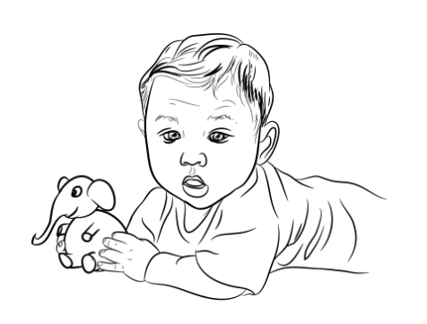
- Seek attention from others
- Play peek-a-boo
- Recognize their name
- Understand “no”
- Understand simple instructions
- Wave to greet or say goodbye
- Imitate familiar words
- Practice words

At 18 months, your child should…
- Use 10 to 20 different words
- Point to some body parts, such as their eyes or nose
- Play with objects appropriately (also known as functional play), such as stacking blocks
- Follow simple commands
- Point or gesture to express their wants and needs
- Engage in verbal turn taking

Contact a speech-language pathologist if your child does not exhibit the following skills by 18 months:
- Use words such as “mama” or “papa/dada”
- Use gestures such as pointing to make requests
- Produce first words



