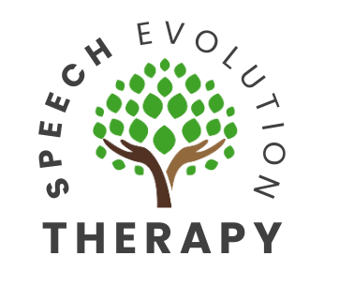
Referral Criteria for Pediatric Speech-Language Evaluation

5 Year Old

Speech, language, and communication play a critical role in children’s school readiness skills and ability to achieve their potential in school. Research shows that children with poor language and literacy skills at a young age have lower education achievement by the age of seven. With an increase in language demands in school, it is important that the months and years leading up to the start of school lay the foundation for future success. Contact a speech-language pathologist if your child is having difficulties with articulation, language, social communication, literacy, and/or troubled behaviors.


At age 5, your child should…
- Use sentences of 5+ words
- Use complex sentences (e.g., I can go in the house after I take off my shoes)
- Follow multi-step instructions to participate in learning activities
- Be 100% intelligible in their speech
- Produce age-appropriate sounds /p, b, m, t, d, n, k, g, f, v, s, z, l, ch, sh,
r, th, y, h, w/
- Possess early literacy skills to learn how to read:
  - Uses or recognizes simple rhymes
  - Answer simple questions about a book or story read to them
  - Tell a story made up of at least two events
- Keep a conversation going with back-and-forth exchanges
- Follow rules and take turns when playing games with other children

Contact a speech-language pathologist if your child does not exhibit the following skills by 5 years old:
- Recognizes shapes, letters, and/or colors
- Able to rhyme
- Able to tell stories
- Initiates and maintains conversations with others



