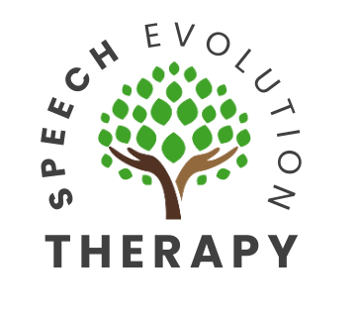
Referral Criteria for Pediatric Speech-Language Evaluation

3 Year Old

The first 3 years of your child’s life is the most intensive period for acquiring speech and language skills. Your child’s brain will develop and mature best in a world that is rich with sounds, sights, and consistent exposure to language. If these critical periods are allowed to pass with little exposure to language, it may be more difficult for future learning. Early identification is key. Contact a speech-language pathologist if your child does not present the following age expected skills.

At age 3, your child should…
- Use 3-4-word phrases and sentences
- Uses words more often than gestures to communicate
- Use different word combinations (e.g., noun + verb, verb + adjective)
- Understand prepositions (e.g., in, on, under)
- Engage in symbolic play (e.g., using brush as a phone)
- Use words for different social functions (e.g., request, comment, ask help)
- Ask Wh- questions, mainly “what” and “where”
- Become familiar with shapes and colors
- Tell simple stories and convey ideas
- Be at least 75% intelligible in their speech

Contact a speech-language pathologist if your child does not exhibit the following skills by 3 years old:
- Uses words more than gestures to communicate
- Uses 2-3-word phrases or sentences
- Engage in pretend play
- Shows a lack of interest in other children



