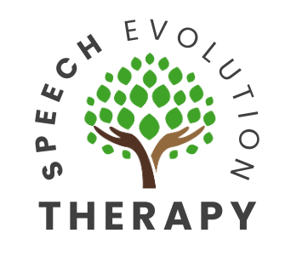
Referral Criteria for Pediatric Speech-Language Evaluation

8 to 12 month old

The first 3 years of your child’s life is the most intensive period for acquiring speech and language skills. Your child’s brain will develop and mature best in a world that is rich with sounds, sights, and consistent exposure to language. If these critical periods are allowed to pass with little exposure to language, it may be more difficult for future learning. Early identification is key. Contact a speech-language pathologist if your child does not present the following age expected skills.
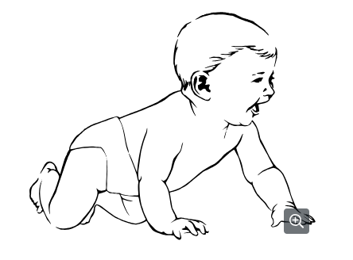
At age 3-6-months, your child should…
- Fix gaze on others’ faces
- Respond to sounds in the environment
- Vary pitch, length, or volume of cries
- Enjoy caregivers’ attention
- Vocalize soft, throaty sounds

At age 6-8-months, your child should…
- Initiate vocalizing to another person
- Respond to speaker by smiling
- Have different vocalizations for different emotional states (anger, contentment, hunger, etc.)
- Attempt to imitate gross motor gestures
- Months 6-7 reduplicated babbling emerges – repeating the same syllable (ba-ba, na-na)

At 8-12-months, your child should…
- Turn head in response to hearing name
- Gesture and/or vocalize to indicate wants and needs
- Attempt to imitate new sounds or actions
- Months 8-9 variegated babbling emerges – mixing different sounds (ba-de-da)
- Months 10-11 jargon emerges – complex babbling with simple words (baba-da-ma-da)
- First true words may emerge around 12 months. For some, first true word do not emerge until later (up to 14 months)

Contact a speech-language pathologist if your child does not exhibit the following skills by 12 months:
- Babbling with consonant sounds
- Responding to name
- Smiling
- Eye contact
- Back and forth smiles and vocalizations in “conversation”



